

Design Document



Final version

Nikola Nikushev

Bilger Yahov

Lyubomir Dimov

Tao Hua

Table of Contents

Introduction 2

Class Diagram 3

Complete view 3

System and Grid classes 4

ComponentDrawn and ToolboxComponent classes 4

Connection Point and Change classes 5

Interfaces 5

Enumerations 5

Description of the classes and their members 6

Sequence Diagrams 7

Creating a component which is not a pipeline (Pump) 7

Editing a component (Splitter) 8

Saving the Grid 9

# 

# Introduction

This document gives information about the class diagram for the *“Flowly”* application. Description of the classes and the attributes and methods in each class is given. Furthermore, some sequence diagrams of the *“Flowly”* system are presented.

The class diagram is a static diagram. It represents the static view of the application. Our class diagram is not only used for visualizing, describing and documenting different aspects of a system but also for constructing executable code of the software application. The class diagram describes the attributes and operations of a class and also the constraints imposed on the system.

Our class diagram can be mapped directly with object oriented languages. It shows a collection of classes, interfaces, associations, collaborations and constraints.

The UML diagrams like activity diagram, sequence diagram can only give the sequence flow of the application but class diagram is a bit different. So it is the most popular UML diagram in the coder community.

In the document can be found sequence diagrams which purpose is:

* Draw the activity flow of a system.
* Describe the sequence from one activity to another.
* Describe the parallel, branched and concurrent flow of the system.

# Class Diagram

## Complete view



## System and Grid classes

 

## ComponentDrawn and ToolboxComponent classes

 

## Connection Point and Change classes

 

## Interfaces



## Enumerations

 

# Description of the classes and their members

# Sequence Diagrams

## Creating a component which is not a pipeline (Pump)

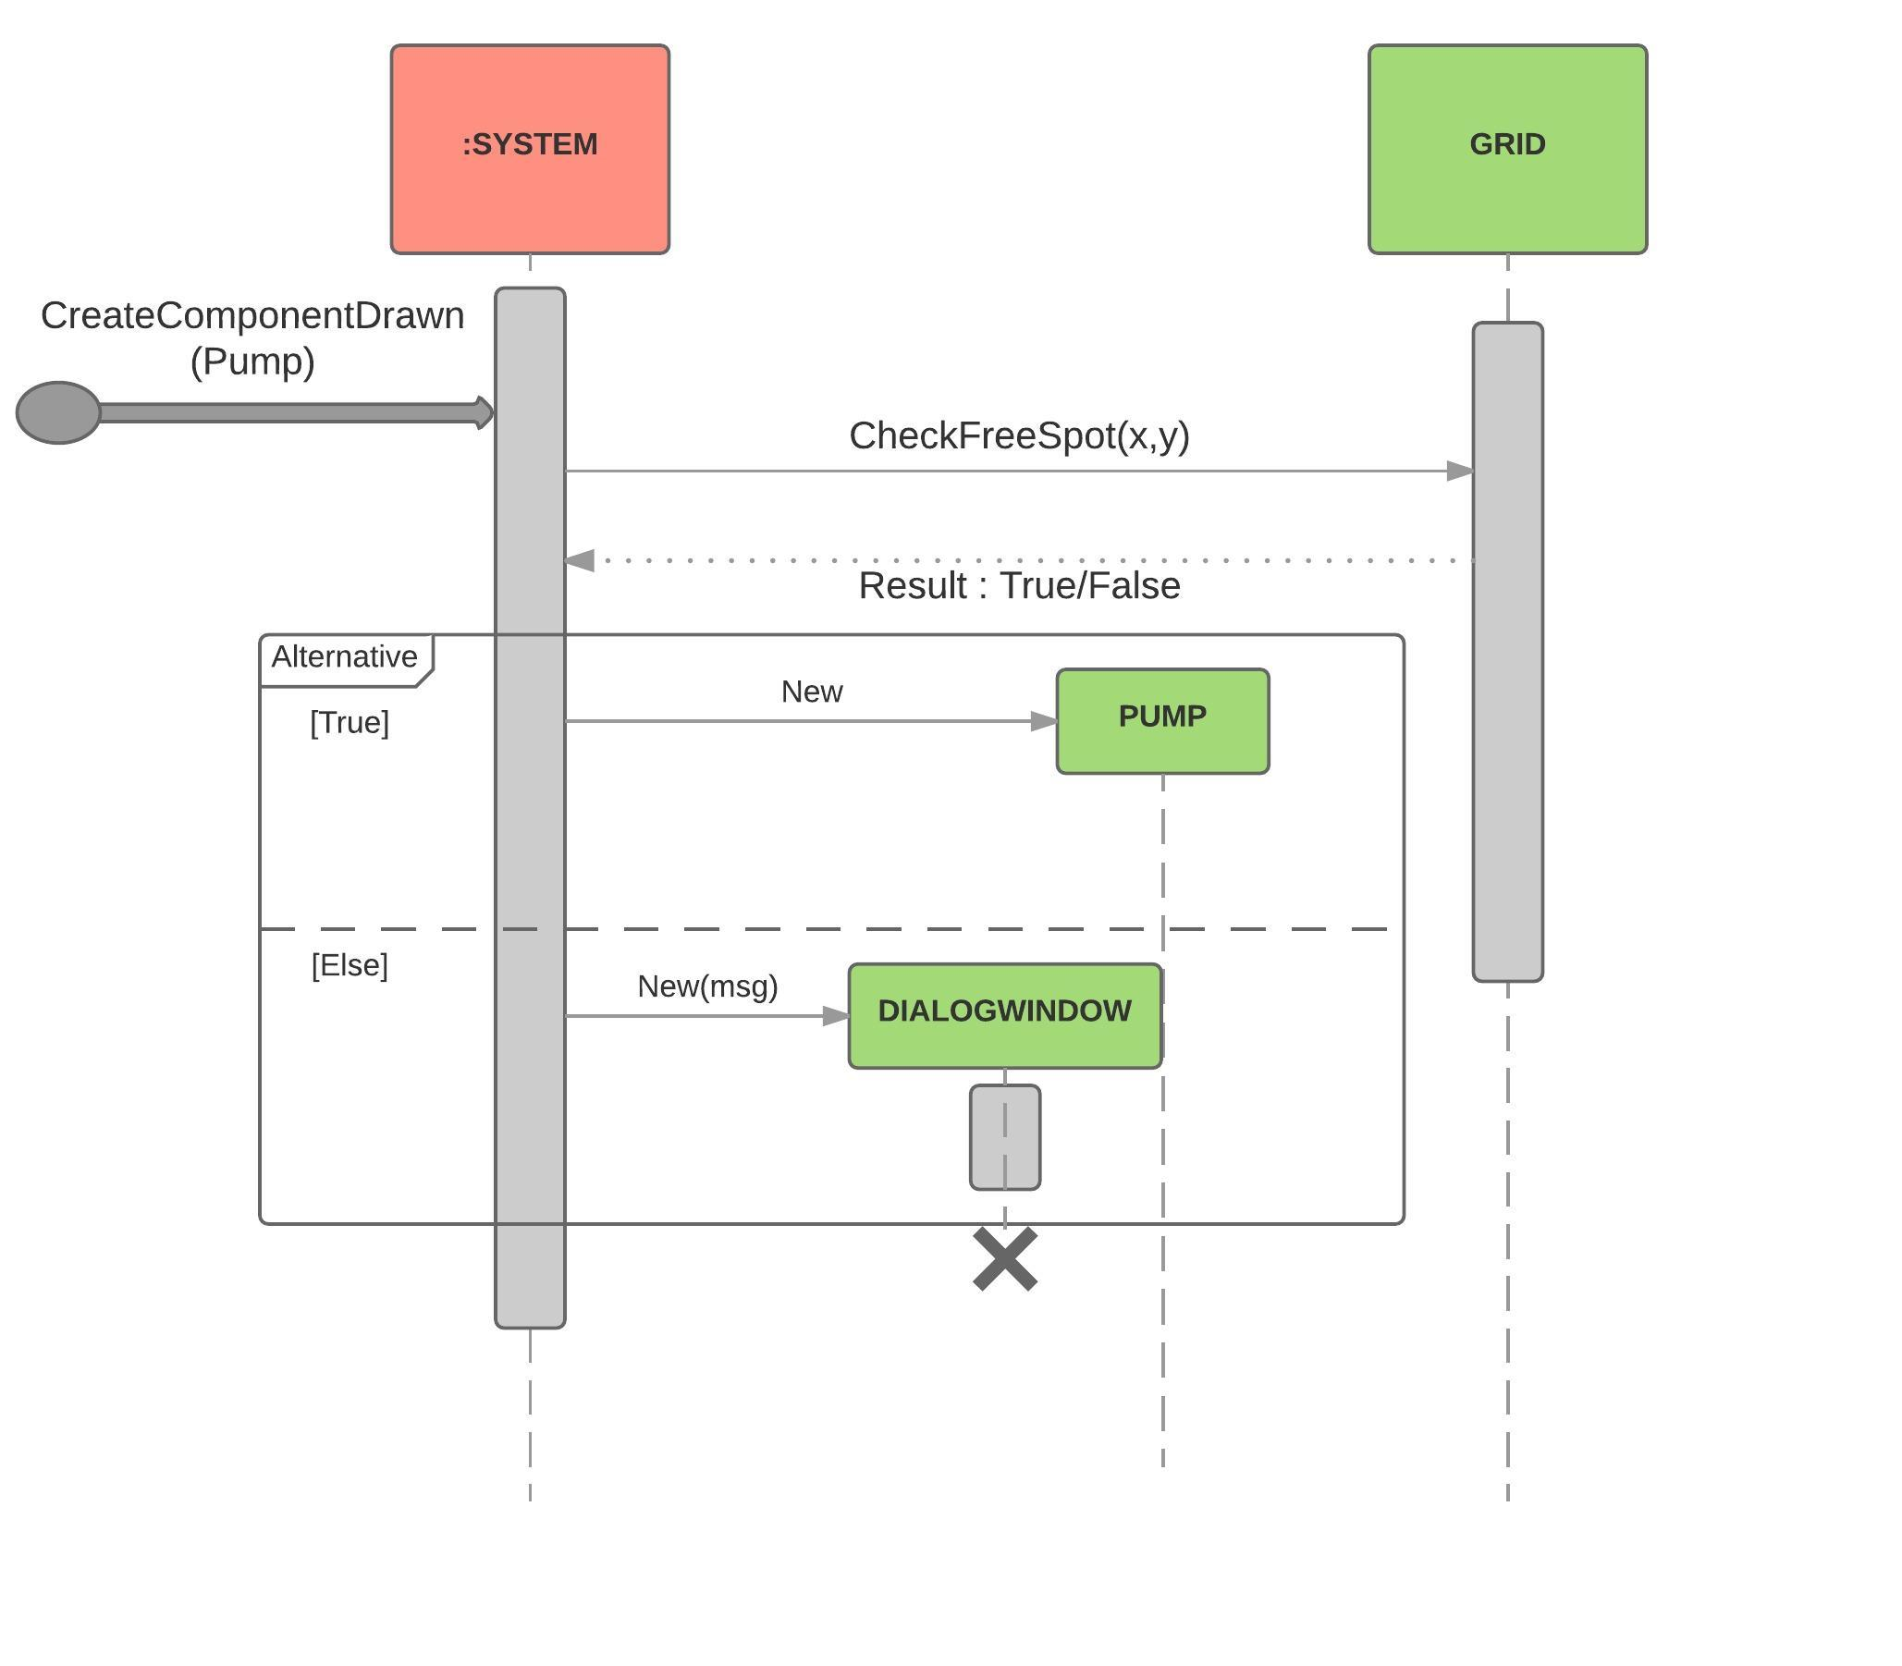

## Editing a component (Splitter)

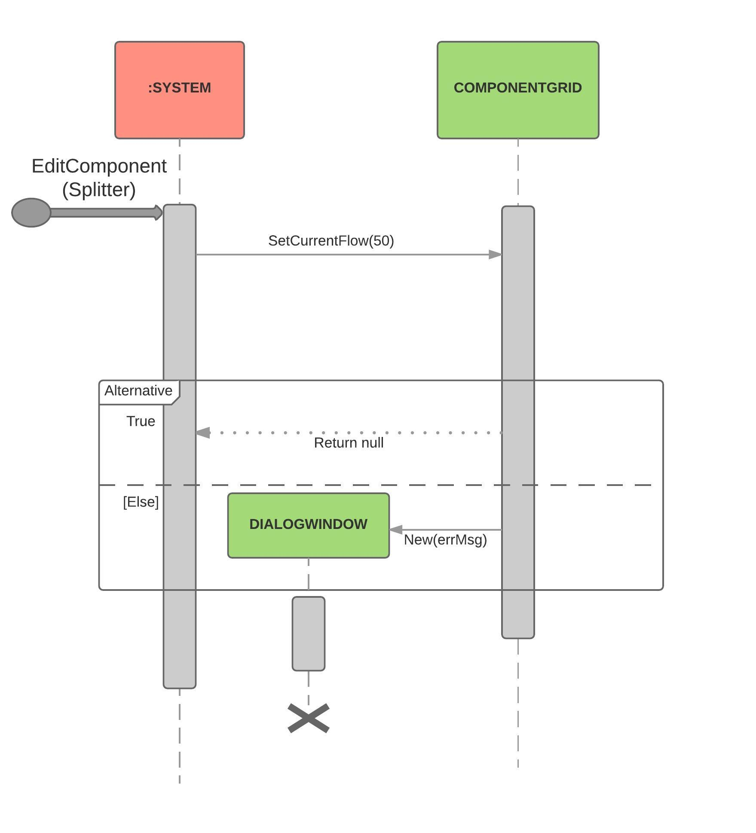

## Saving the Grid

